Another supply and demand puzzle
The market price of calzones in a college town increased recently, and the students in an economics class are debating the cause of the price increase. Some students suggest that the price increased because several pizza parlors in the area have recently gone out of business. Other students attribute the increase in the price of calzones to a recent increase in college student enrollment.
The first group of students thinks the increase in the price of calzones is due to the fact that several pizza parlors in the area have recently gone out of business.
On the following graph, adjust the supply and demand curves to illustrate the first group’s explanation for the increase in the price of calzones.
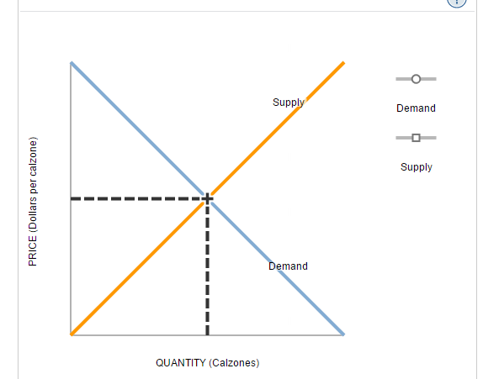
The second group of students attributes the increase in the price of calzones to the increase in college student enrollment.
On the following graph, adjust the supply and demand curves to illustrate the second group's explanation for the increase in the price of calzones.

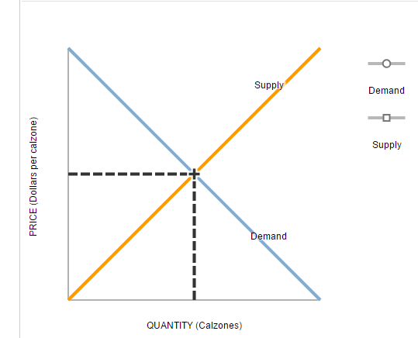

Suppose that both of the events you have just analyzed are partly responsible for the increase in the price of calzones. Based on your analysis of the explanations offered by the two groups of students, how would you figure out which of the possible causes was the dominant cause of the increase in the price of calzones?
If the equilibrium quantity of calzones decreases, then the supply shift in the market for calzones must have been larger than the demand shift.
If the price increase was large, then the supply shift in the market for calzones must have been larger than the demand shift.
If the equilibrium quantity of calzones decreases, then the demand shift in the market for calzones must have been larger than the supply shift.
Whichever change occurred first must have been the primary cause of the change in the price of calzones.

